
Laidley District
State School

2024-2027
Student
Code of Conduct
Equity and Excellence: realising the potential of every student
Equity and Excellence outlines the government's vision for a progressive, high-performing education system. Equity and Excellence provides clarity for schools about priorities and expectations, with differentiated support targeted to each school's context and needs.
Queensland Department of Education

Contact Information

Postal address: | 232 Patrick Street, Laidley, 4341
Phone: | 07 5466 8222
Email: | principal@laidleydistrictss.eq.edu.au
School website address: | www.laidleydistrictss.eq.edu.au
Contact Person: | Ms Leanne Stewart (Principal)

Endorsement

Principal Name: | Ms Leanne Stewart
Principal Signature:
Date:
P/C President and-or School Council Chair Name:
P/C President and-or School Council Chair Signature:
Date:

Contents

Purpose 4

Principal’s Foreword 5

P&C Statement of Support 6

School Captains’ Statement 7

Consultation 8

Learning and Behaviour Statement 9

Multi-Leveled Systems of Support 9

Student Wellbeing 11

Student Support Network 12

Whole School Approach to Discipline 14

Behaviour Expectations 14

Rewarding Positive Behaviour 17

Responding to Unacceptable Behaviour 18

Consideration of Individual Circumstances 19

Differentiated and Explicit Teaching 20

Focussed Teaching 22

Intensive Teaching 23

Legislative Delegations 24

Legislation 24

Delegations 24

Disciplinary Consequences 25

Major & Minor Behaviours 26

Behaviour Flowcharts 27

School Policies 31

Temporary removal of student property 31

Use of mobile phones and other devices by students 33

Preventing and responding to Mean on Purpose Behaviour (bullying) 34

Appropriate use of social media 37
Restrictive Practices 40

Critical Incidents 41

Related Procedures and Guidelines 42

Resources 43

Conclusion 44

Purpose

Laidley District State School is committed to providing a safe, respectful and disciplined learning environment for all students, staff, parents and visitors.

Laidley District State School’s Student Code of Conduct is designed to facilitate high standards of behaviour to provide innovative opportunities that empower students, embrace diversity and engage our community through the core values of being respectful, responsible, resilient and ready to learn.

Its purpose is to facilitate high standards of behaviour from all in the school community, ensuring learning and teaching in our school is prioritised, where all students are able to experience success and staff enjoy a safe workplace.

Principal’s Foreword
Introduction
Laidley District State School has a long and proud tradition of providing high quality education to students. We believe strong, positive relationships between all members of our school are the foundation to supporting the success of all students.

This school began its journey in 2000, as an amalgamation of Laidley North, Laidley Central and Mulgowie State Schools after their respective closures. At this time, the school was primarily rebuilt on the grounds of the old Laidley North State School site, which means that today we enjoy exceptional facilities and extensive landscaping – a superb school to learn and play in. Our school is truly the heart of the Laidley community, and enjoys strong partnerships with a wide range of community stakeholders.

A comprehensive recent review spoke highly of the friendly and welcoming environment Laidley District embodies, as well as acknowledging the tremendous work of staff to ensure success for every student in our care.

Laidley District State School has four core values: I AM Respectul, I AM Responsible, I AM Resilient and I AM Ready to learn.

Respectful to self and others

Responsible accountable for your actions, resolve differences in constructive, non-violent and peaceful ways, contribute to society and civic life and take care of the environment

Resilient never give up; try at everything; persevere through triumphs and difficulties, hold your head high

Ready to learn ready and prepared for all lessons, complete set tasks, ask for help as needed

These values have been used in the development of this Student Code of Conduct, with the aim of helping shape and build the skills of all our students to be confident, self-disciplined and kind young people. Our school staff believe that communication and positive connections with other people are the most valuable skills our communities need now and in the future.

Laidley District State School staff take an educative approach to discipline, that behaviour can be taught and that mistakes are opportunities for everyone to learn. Our Student Code of Conduct provides an overview of the school’s local policies on use of mobile phones and other technology, removal of student property and the approach to preventing and addressing incidents of mean on purpose behaviour. It also details the steps school staff take to educate students about these policies and how students are explicitly taught the expected behaviours. Finally, it details the consequences that may apply when students breach the expected standards of behaviour, including the use of suspension or exclusion.

I thank the students, teachers, parents and other members of the community for their work in bringing this Laidley District State School Student Code of Conduct together. Your interest and views shared through the process of developing this document have been invaluable. It provides a clear explanation of what we expect from students and how we will support them to meet those expectations.

P&C Statement of Support

As president of the Laidley District State School P&C Committee, I am proud to support the new Student Code of Conduct.

We encourage all parents to familiarise themselves with the Laidley District State School Student Code of Conduct, and to take time to talk with their children about the school expectations, multi-tiered systems of support, student support network, the whole school approach to discipline, reward system for acknowledging positive behaviour, and discuss any additional support they may need.

Throughout the year, we will continue to work with the school administration team on how the Student Code of Conduct is working, identify areas for improvement, and present alternative options or suggestions for consideration.

Any parents who wish to discuss the Laidley District State School’s Student Code of Conduct and the role of families in supporting the behavioural expectations of students are welcome to contact myself or to join the Laidley District State School P&C Association. It is with your support that we can work collaboratively with school staff to ensure all students are safe, and appropriately supported to meet their individual social, emotional, and learning needs.

School Captains/Leaders Statement

On behalf of the student body at Laidley District State School, we endorse the Student Code of Conduct for 2024-2027. We have represented students on the consultation committee, provided feedback on draft materials and put forward the views of young people on a range of issues affecting their lives at school. Throughout the year, we will continue to work with the school administration team and Laidley District State School P&C Association on how the Student Code of Conduct is working, identify areas for improvement and present alternative options or suggestions for consideration.

Any student who has questions or issues they would like raised by the School Captains are first encouraged to talk with their class representative, however you are also invited to approach any of us directly.

School Captain Name:

Signature:

Date:

School Captain Name:

Signature:

Date:

Consultation

The consultation process used to inform the development of the Laidley District State School Student Code of Conduct occurred in two phases.

In the first phase, we held a series of internal meetings with staff between Term 2 and Term 3 2023. During these meetings, we examined a range of data sets on student and staff attendance, school disciplinary absences (SDA) and outcomes from the most recent School Opinion Survey. We identified strengths and successes from our previous school behaviour plan, and areas for further development.

In the second phase, a draft Student Code of Conduct was prepared and distributed for comment to all members of the school community. The second phase of consultation was completed in October 2023, and the finished version, incorporating suggested changes and feedback, was sent to the P&C Association meeting in November 2023 for endorsement. The P&C Association unanimously endorsed the Laidley District State School Student Code of Conduct for implementation in 2024.

A communication strategy has been developed to support the implementation of the Laidley District State School Student Code of Conduct, including parent information evenings, promotion through the school website, social media accounts, the fortnightly newsletter and enrolement packs. Any families who require assistance to access a copy of the Laidley District State School Student Code of Conduct, including translation to a suitable language, are encouraged to contact the principal.

Review Statement
The Laidley District State School Student Code of Conduct will undergo annual minor updates to reflect changing circumstances, data and staff. A fulsome review is conducted every four years in line with the scheduled review process for the School Planning, Reviewing and Reporting cycle.

Learning and Behaviour Statement
Everyone brings their own sets of personal beliefs to a school community. These beliefs influence their decisions, behaviour and social practices. It is reasonable to expect that not everyone will share the same sets of beliefs, and this contributes to a richly diverse social environment in each school. It can also contribute to differences in expectations and force us to reflect on our own understanding of what we consider acceptable and unacceptable. We encourage any student or parent to make an appointment with the principal to discuss the model of behaviour support and discipline used at this school.

Multi-Tiered Systems of Support

Laidley District State School takes a Positive, Proactive and Preventative approach to behaviour management using a multi-tiered system of support (MTSS). MTSS is a preventative, differentiated model grounded in practical strategies, targeted planning and data-informed decision-making. Based on a problem-solving model, in MTSS, school staff match increasingly intensive interventions to the identified needs of individual students, including emotional intelligence.

Tier | Prevention Description
1 | All students (100%) in the school receive support for their academic and behavioural development. Focus is on the whole-school implementation of both the Australian Curriculum General Capabilities and UR Strong Friendology expectations. This involves all staff:  - having consistent and high expectations of behaviour following our whole school behaviour process, based on Effective Classroom Management  - having clearly established, explicitly taught, visible expectations that are referred to regularly, and retaught as needed  - teaching the behaviours expected to be used in the appropriate settings  - being consistent when addressing challenging behaviour, while taking developmental norms and behavioural function into account  - providing refresher lessons and targeted recognition throughout the school year so skills are ready and likely to be used when students need them  - providing SET teacher or teacher aide support as required  - providing differentiated teaching to respond to the learning needs of all students  - encouraging active engagement and particiapation  - free and frequent positive reinforcement of expected behaviour  - behaviour trackers for UR Strong Mean on Purpose behaviours
2 | Targeted instruction and supports for some students (10-15%) are more intense than Tier 1 services, providing more time and specialisation in services from a range of school-based staff to enable students to meet the required academic and behavioural standards.  Tier 2 supports build on the supports provided at Tier 1, and may prevent the need for more intensive interventions. Tier 2 supports are provided to small groups of students as required, offering more time and/or explicit instruction in particular aspects of UR Strong expectations. The types of interventions offered at this level will vary according to the needs of each student and may include:  - B Block (support services block) and/or PBC small group intervention and support  - reinforcement of UR Strong strategies including, ‘talk it out bench’ and ‘quick comebacks’  - individual playground timetable or check-in  - individual behaviour action plan from UR Strong implemented by classroom teacher  - social skills programs implemented by Inclusion Teacher, Social Worker, Chaplain or Guidance Officer  - individual behaviour support plan  If the school data indicates that more than 10-15% of students require targeted services, then a review of Tier 1 is needed to address the basic implementation and quality of instruction.
3 | Individualised services for few students (2-5%) who require the most intensive support a school can provide. These are usually delivered in very small groups or on an individual basis.  Tier 3 supports continue to build on the lessons and supports provided at Tiers 1 and 2, becoming more individualised and more intensive until teams can identify what is needed for a student to be successful. Tier 3 supports are based on the underlying reasons for a student’s behaviour identified in their Functional Behaviour Assessment (FBA), if applicable, and should include strategies outlined in their Individual Behaviour Support Plan (IBSP) which:  - PREVENT problem behaviour  - TEACH the student an acceptable replacement behaviour  - REINFORCE the student’s use of the replacement behaviour  - MINIMISE the payoff for problem behaviour  Some strategies used include:  - individual playground supervision timetable  - B Block or PBC used to support and regulate individuals  - behaviour action plan from UR Strong for individuals implemented by administration  - functional behaviour assessment  - individual behaviour support plan  - risk assessment – behaviour, safety and wellbeing  - discipline improvement plan  Tier 3 supports exist along a continuum. Many students can benefit from a simple (or brief) FBA that identifies unique strategies to help the student achieve success. A smaller percentage of students may require a more comprehensive FBA that includes a more thorough process for data collection, collaboration, and problem solving. A much smaller percentage of students may need an intensive FBA and wraparound plan that includes personnel from outside agencies and rigorous problem solving procedures.  If the school data indicates that more than 2-5% of the student population requires individualised services, a review of Tier 1 and Tier 2 supports and organisation is recommended.

Student Wellbeing and Support Network

Laidley District State School offers a range of programs and services to support the wellbeing of students in our school.

Our overarching behaviour program which supports emotional intelligence and wellbeing is UR Strong Friendology 101.

We encourage parents and students to speak with their class teacher or make an appointment to meet with the guidance officer if they would like individual advice about accessing particular services.

Learning and wellbeing are inextricably linked — students learn best when their wellbeing is optimised, and they develop a strong sense of wellbeing when they experience success in learning. The student learning and wellbeing framework supports state schools with creating positive school cultures and embedding student wellbeing in all aspects of school life through connecting the learning environment, curriculum and pedagogy, policies, procedures and partnerships for learning and life.

Curriculum and pedagogy
The UR Strong Friendology 101 program was developed to work in partnership with UR Strong Schools and communities to provide a clear plan of action to help prevent “mean-on-purpose” (bullying) behaviour in children.

This program centres on a school-wide positive relationship strategy, designed to shift schools towards a culture of kindness and respect. The key factors include:
- A consistent, whole-school approach so that teachers and parents are using the same language to support students.
- A skills-based strategy that empowers students to self-govern and make healthy choices in their relationships.
- Kid-friendly language and pedagogy that promotes learning, retention, and application of knowledge and skills.
A proactive system that teaches interpersonal skills and conflict-resolution at a young age.

Schools build the foundations for wellbeing and lifelong learning through curriculum embedding personal and social capabilities (self-awareness, self-management, social awareness and social management) in the implementation of the P–12 curriculum, assessment and reporting framework.

As a school we acknowledge the positive impact that a meaningful relationship between teacher and students can have on students' academic and social outcomes.

Policy and expectations
Within a school community there are specific health and wellbeing issues that will need to be addressed for the whole school, specific students, or in certain circumstances.

Specialised health needs
Laidley District State School works closely with parents to ensure students with specialised health needs, including those requiring specialised health procedures, have access to a reasonable standard of support for their health needs whilst attending school or school-based activities.

This means that appropriate health plans are developed and followed for students with specialised health needs, that staff are aware of the student's medical condition and that an appropriate number of staff have been trained to support the student's health condition.

Medications
Laidley District State School requires parent consent and medical authorisation** to administer any medication (including over-the-counter medications) to students. For students requiring medication to be administered during school hours, the school can provide further information and relevant forms. All medications are required to be provided to the school in labelled and meter dosage packets, i.e., Webster packs or similar. Staff will not alter provided medications, for example, split a tablet into two halves for a half dose.

For students with a long-term health condition requiring medication, parents need to provide the school with a Request to administer medication at school form signed by the prescribing health practitioner.

** The administration of medications to students by school staff is only considered when a prescribing health practitioner has determined that it is necessary or when there is no other alternative in relation to the treatment of a specific health need. Schools require medical authorisation to administer any medication to students (including over-the-counter medications such as paracetamol or alternative medicines).

Student Support Network
Laidley District State School is proud to have a comprehensive Student Support Network in place to help the social, emotional and physical wellbeing of every student. In addition to the assistance provided by class teachers, we have a team of professionals whose dedicated roles are to help ensure our school is an inclusive, nurturing environment.

Students can approach any trusted school staff member at Laidley District State School to seek assistance or advice. If they are unable to assist they will provide guidance and help ensure the student is connected to the appropriate representative of the Student Support Network.

Parents who would like more information about the student support roles and responsibilities are invited to contact the principal.

Role | What they do
Student Council | - a body of student representatives who advocate for their peers and the change they wish to see in the school.
Community Education Counsellor (CEC) | - provides educational counselling and support services to Aboriginal and/or Torres Strait Islander students and communities.
Guidance Officer | - provides a comprehensive student support program within the school environment offering counselling with students on a one-on-one basis or in a group setting  - assists students with specific difficulties, acting as a mediator or providing information on other life skills  - liaises with parents, teachers, or other external health providers as needed as part of the counselling process.
Anglicare | - provides counselling and support for families and students regarding routines, conflicts, school engagement, overall health and wellbeing.
Speech-Language Pathologist | - provides assessment for student development in the area of speech-language support  - constructs and supports the implementation of support programs for student development.
Partnership with Kambu Medical and Wellbeing Centre | - provides support for Indigenous families requiring assistance in any facet of lifestyle, health, wellbeing.
School-Based Youth Health Nurse | - provides individual health consultations with assessment, support, health information and referral options related to:  - healthy eating and exercise  - relationships  - personal and family problems  - feeling sad, worried and angry.
Regional Based School Nurse | - works with school staff to build their competence and confidence to safely manage procedures and interventions required by students with specialised health needs  - provides assessment, health management planning, training and ongoing support and supervision for students with specialised health needs.
Chaplain | - provides individual and, at times, group support to students to assist their engagement with education and training  - support students to overcome barriers to education such as  - attendance at school  - learning support  - suspension/exclusion/referral for behaviour support  - relationships/social skills  - conflict with family/peers/teachers  - social/emotional/physical wellbeing.

It is also important for students and parents to understand there are regional and statewide support services also available to supplement the school network. These include Principal Advisor Student Protection, Mental Health Coach, Autism Coach, Inclusion Coach, Success Coach, Advisory Visiting Teachers and Senior Guidance Officers. For more information about these services and their roles, please speak with the Principal.

Whole School Approach to Discipline

At Laidley District State School we believe discipline is about more than punishment. It is a word that reflects our belief that student behaviour is a part of the overall teaching and learning approach in our school. Our staff take responsibility for making their expectations clear, for providing supportive instruction about how to meet these expectations and strive to use behavioural incidents as opportunities to re-teach. All areas of Laidley District State School are learning and teaching environments. We consider behaviour management to be an opportunity for valuable social learning as well as a means of maximising the success of academic education programs.

Our Student Code of Conduct outlines our system for facilitating student well-being and positive behaviours, preventing problem behaviour and responding to unacceptable behaviours. Shared expectations for student behaviour are explicit to everyone, assisting Laidley District State School to create and maintain a positive and productive learning and teaching environment, where all school community members have clear and consistent expectations and understandings of their role in the educational process.

Laidley District State School’s Student Code of Conduct reflects the values of our community.
Our Values: I AM;
- Respectful
- Responsible
- Resilient
- Ready to learn

Positive and productive partnerships with parents and carers is key to ensure success for any behaviour strategy. Consistency in messages to students is essential. Parent/carer partnerships are required throughout each of the multi-tiered systems of support.

Students
Below are examples of what these expectations look like for students across the school. In addition, each classroom will have their own set of examples to help students and visitors understand the expectations and meet the standards we hold for everyone at Laidley District State School .The tables below explain the expectations for parents when visiting our school and the standards we commit to as staff.

Respectful
- Say “please” and “thank you”.
- Look for opportunities to help others.
- Make a new friend.
- Give someone a compliment.
- Listen to fellow students’ questions in class.
- Put rubbish in the bins provided.
- Use G rated language at school.
- Respect others space and belonging.

Responsible
- Follow teachers directions.
- Hand in items you find to the teacher.
- Be honest.
- Right place, right time.

Resilient
- Do your own work.
- Learn from your mistakes.
- Accept consequences for your actions.
- Develop a growth mindset.

Ready to learn
- Be prepared for class.
- Complete your homework and assignments on time.
- Ask for help when needed.
- Be an active listener.

Parents and staff
Our staff are committed to delivering a high quality of education for every student, and believe all adults in the school, whether visiting or working, should meet the same expectations in place for students. At Laidley District State School, we demonstrate: respectful, responsible, resilient and ready to learn attributes.

Respectful

What we expect to see from you | What you can expect from us
You make an appointment to speak with the class teacher or principal to discuss any matters relating to your child. | We will respond as soon as practicable to your request for an appointment and negotiate a mutually agreeable date and time with you.
You are respectful in your conversations at home about school staff. | We will ensure positive behaviours are role modelled for all students.
You respect school, student and staff privacy in your online communications. | We will act quickly to address social media issues that affect staff, students or families.
You recognise people are different and will be non-judgemental, fair and equitable to others in the school community. | We will welcome and celebrate a diverse school community with recognition of significant social, cultural and historical events.
You help your child to see the strengths and benefits in diversity and difference in their classmates. | We will promote every child’s individuality and build a cohesive, inclusive classroom and school culture.
You respect the obligation of staff to maintain student and family privacy. | We will maintain confidentiality about information relating to your child and family.

Responsible
What we expect to see from you | What you can expect from us
You share relevant information about your child’s learning, social and behavioural needs with school staff. | We will share relevant information with you about your child’s learning, social and behavioural progress at school.
You approach the class teacher or principal if you are concerned about the behaviour of a staff member, another student or parent. | We will work with every family to quickly address any complaints or concerns about the behaviour of staff, students or other parents.
You seek out opportunities to provide positive feedback to the classroom teacher about their work with the class, a student or colleagues. | We will work closely with families to accommodate their personal needs, including work commitments, finances and family structure.
You notice when others need help, parents, staff and students, and ask if there is anything you can do to assist. | We will check in with you about your child’s needs or any support your family may require.
You ensure your children attend school every day and notify the school promptly of any absences or changes in contact details. | We will create a safe, supportive and inclusive environment for every student.

Resilient

What we expect to see from you | What you can expect from us
You take a positive, solution-focused approach to resolving complaints. | We will nominate a contact person for you to work with to resolve a school related complaint.

Ready to learn

What we expect to see from you | What you can expect from us
You support your child to meet the learning and behavioural expectations at school. | We are clear about our learning and behavioural expectations, and contact you to provide regular feedback about your child’s progress.
You stay informed about school news and activities by reading the school newsletter and other materials sent home by school staff. | We will use the electronic school newsletter as the primary means of notifying parents about school news, excursions or events.

Rewarding Positive Behaviour

The following school wide approach to rewarding positive behaviour is to be used freely and frequently.

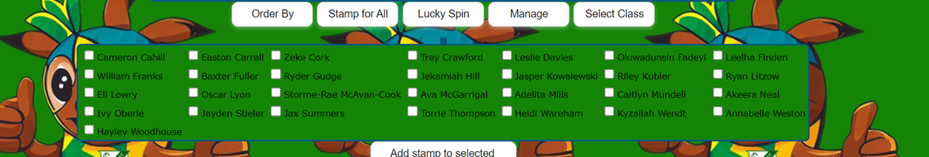
At LDSS we use a positive engagement and reward system that includes a whole school electronic collection point linked to class and school wide positive behaviour expectations. Points will be distributed by staff during classroom and playground activities, to students who have displayed and acted positively upon Laidley District’s whole school expectations. Students can exchange their points for a reward on their class rewards menu.

Each classroom will have their own class rewards menu which will be negotiated with the classroom teacher and students. Whole class points will be given to the whole class when they all display the schools’ expectation at the same time. Once the class has their agreed upon points, they will participate in a whole class negotiated reward e.g. 15 minutes’ free time, picnic at lunch etc.
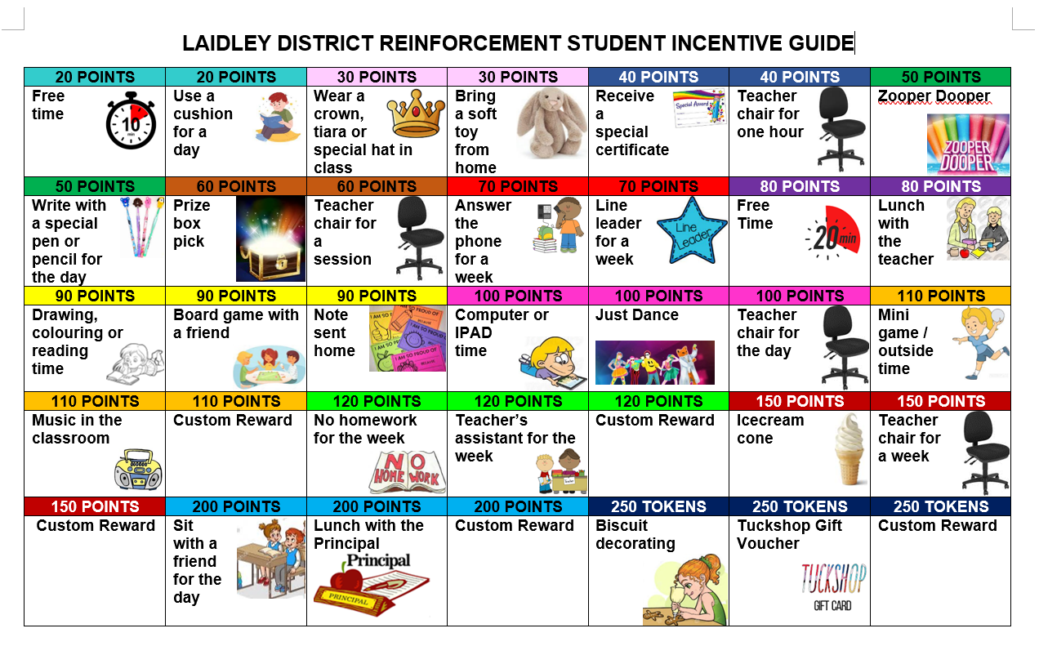
Example of a reinforcement menu.

A formal recognition and monitoring system has been developed. This reinforcement system is designed to increase the quantity and quality of positive interactions between students and staff.

- Schoolwide Recognition
Laidley Legend Badges – tiered in Bronze, Silver and Gold. Students complete an application for each level, based on the school values and attendance greater than 93%.

- Rewards Day
Rewards Day happens every term to celebrate the great behaviour of the students who do the right thing. All students are eligible to attend rewards day activities each term, unless they have been issued with a school suspension during that term. This data is generated from the OneSchool referrals.

- The House Trophy
We have 4 houses – Narda, Warrego, Cunningham and Liverpool. For different areas and events within the school, individuals can earn House Points for their School Houses. i.e. Parade certificates, music endeavours, in morning line-up under E Block, or other curriculum or community advancement. Each week on parade, the weekly tally of House points will be announced. At the end of the term the winning house is presented with the House Trophy.

Responding to unacceptable behaviour

Students come to school to learn. Behaviour support represents an important opportunity for learning how to get along with others.

- Re-directing low-level and infrequent problem behaviour

When a student exhibits low-level and infrequent problem behaviour, the first response of school staff members is to remind the student of expected school behaviour by using the reflection questions, then ask them to change their behaviour so that it aligns with our school’s expectations. Our preferred way of re-directing low-level problem behaviour is to ask them to think of how they might be able to act more respectfully, more responsibly or with more resilience. This encourages students to reflect on their own behaviour, evaluate it against expected school behaviour, and plan how their behaviour could be modified so as to align with the expectations of our school community. Utilising the UR Strong Friendology 101 Program, students are taught the skills to manage Friendship Fires and Mean-on-Purpose behaviours.

- Targeted behaviour support:
- Playground and Classroom Monitoring

These are the students at Laidley District State School who are identified through our data as needing targeted behavioural support. In most cases the problem behaviours of these students may not be immediately regarded as severe, but the frequency of their behaviours may put these students’ learning and social success at risk if not addressed in a timely manner. Students are monitored from OneSchool data and followed up according to the Office Referral for Classroom Behaviour and the Playground Referral. All staff members are provided with continuous professional development consisting of an overview of the program, the referral and response process, and the reporting responsibilities of staff and of the students being supported - Debriefing Report.

Students whose behaviour indicates a need for specialised intervention, are provided with intensive behaviour support and are referred to the Student Support Services (SSS) Meeting.

Intensive behaviour support: Behaviour Support Team

Laidley District State School is committed to educating all students, including those with the highest behavioural support needs. We recognise that students with highly complex and challenging behaviours need comprehensive systems of support. The Intensive Behaviour Support Team:
- works with other staff members to develop appropriate behaviour support strategies
- monitors the impact of support for individual students through continuous data collection
- makes adjustments as required for the student
- works with the School Behaviour Leadership Team to achieve continuity and consistency
- supervises play for individual student support, and
- construct rostered areas for designated play.

Consideration of Individual Circumstances

Staff at Laidley District State School take into account students’ individual circumstances, such as their behaviour history, disability, mental health and wellbeing, religious and cultural considerations, home environment and care arrangements when teaching expectations, responding to inappropriate behaviour or applying a disciplinary consequence.

In considering the individual circumstances of each student, we recognise that the way we teach, the support we provide and the way we respond to students will differ. This reflects the principle of equality, where every student is given the support they need to be successful. This also means that not everyone will be treated the same, because treating everyone the same is not fair. For example, some students need additional support to interpret or understand an expectation. Others may benefit from more opportunities to practise a required skill or behaviour. For a small number of students, the use of certain disciplinary consequences may be considered inappropriate or ineffective due to complex trauma or family circumstances. These are all matters that our teachers and principal consider with each individual student in both the instruction of behaviour and the response to behaviour.

Our teachers are also obliged by law to respect and protect the privacy of individual students, so while we understand the interest of other students, staff and parents to know what punishment another student might have received, we will not disclose or discuss this information with anyone but the student’s family. This applies even if the behavioural incident, such as ‘mean-on-purpose’ behaviour, involves your child. You can be assured that school staff take all matters very seriously and will address them appropriately. We expect that parents and students will respect the privacy of other students and families and respect the decisions made by the principal or their delegate when dealing with behaviour incidents.

If you have concerns about the behaviour of another student at the school, or the way our staff have responded to their behaviour, please make an appointment with the principal to discuss the matter.

Differentiated and Explicit Teaching

Laidley District State School is a disciplined school environment that provides differentiated teaching to respond to the learning needs of all students. This involves teaching expected behaviours and providing opportunities for students to practise these behaviours. Teachers reinforce expected behaviours, provide feedback and correction, and opportunities for practise.

Teachers at Laidley District State School vary what students are taught, how they are taught and how students can demonstrate what they know as part of this differentiated approach to behaviour. These decisions about differentiation are made in response to data and day-to-day monitoring that indicates the behavioural learning needs of students. This enables our teachers to purposefully plan a variety of ways to engage students; assist them to achieve the expected learning; and to demonstrate their learning.

The class teacher is responsible for providing in-class or in-school disciplinary responses to low-level or minor problem behaviour. This may include:
- Pre-correction (e.g. “Remember, walk quietly to your seat”)
- Non-verbal and visual cues (e.g. posters, hand gestures)
- Whole class practising of routines
- Ratio of 5 positive to 1 negative commentary or feedback to class
- Corrective feedback (e.g. “Hand up when you want to ask a question”)
- Rule reminders (e.g. “When the bell goes, stay seated until I dismiss you”)
- Explicit behavioural instructions (e.g. “Pick up your pencil”)
- Proximity control
- Tactical ignoring of inappropriate behaviour (not student)
- Revised seating plan and relocation of student/s
- Individual positive reinforcement for appropriate behaviour
- Classwide incentives
- Reminders of incentives or class goals
- Redirection
- Low voice and tone for individual instructions
- Give appropriate ‘take-up’ time for student/s to process instruction/s
- Reduce verbal language
- Break down tasks into smaller chunks
- Provide positive choice of task order (e.g. “Which one do you want to start with?”)
- Prompt student to take a break or time away in class
- Model appropriate language, problem solving and verbalise thinking process (e.g. “I’m not sure what is the next step, who can help me?”)
- Provide demonstration of expected behaviour
- Peer consequence (e.g. corrective feedback to influential peer demonstrating same problem behaviour)
- Private discussion with student about expected behaviour
- Reprimand for inappropriate behaviour
- Warning of more serious consequences (e.g. removal from classroom)
- Detention

There are three main layers to differentiation, as illustrated in the diagram below. This model is the same used for academic and pedagogical differentiation.
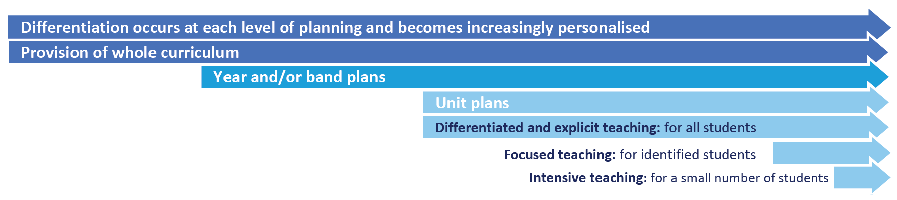
These three layers map directly to the tiered approach discussed earlier in the Learning and Behaviour section. For example, in the PBL framework, Tier 1 is differentiated and explicit teaching for all students, Tier 2 is focussed teaching for identified students and Tier 3 is intensive teaching for a small number of students. Each layer provides progressively more personalised supports for students.

Every classroom in our school uses the Expectations Matrix, illustrated below, as a basis for developing their behaviour standards. Using this matrix, the class teacher works with all students to explain exactly what each of the expectations look, sound and feel like in their classroom. The completed matrix is on display in every classroom, used as the basis of teaching expectations throughout the year and revisited regularly to address any new or emerging issues.
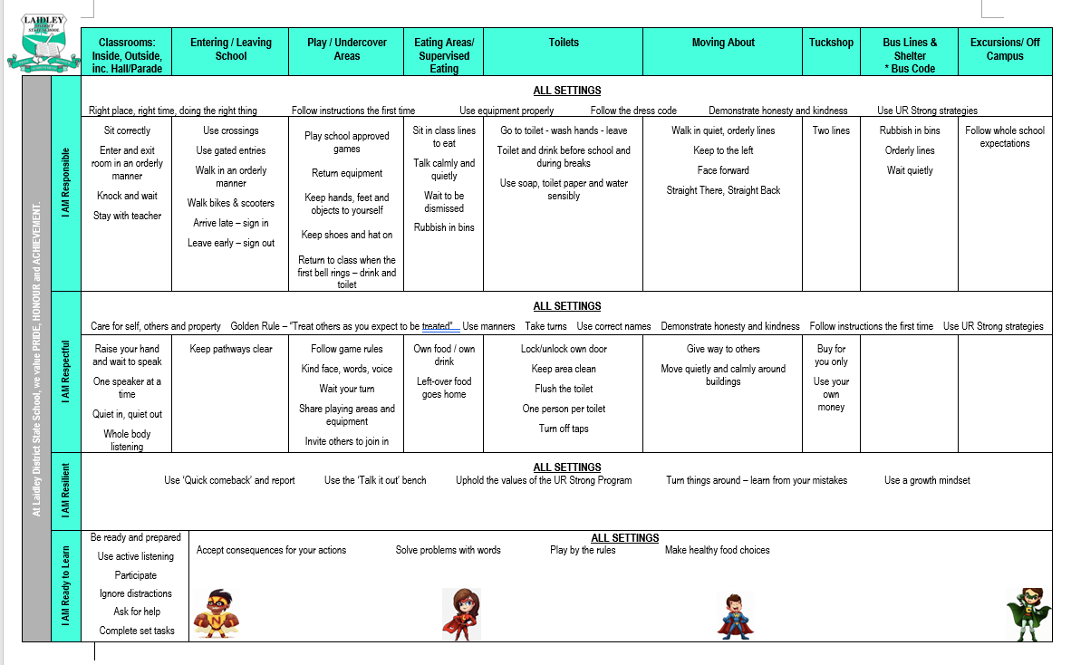

The first step in facilitating standards of positive behaviour is communicating those standards to all students. At Laidley District State School, we emphasise the importance of directly teaching students the behaviours we want them to demonstrate at school. Communicating behavioural expectations is a form of universal behaviour support - a strategy directed towards all students designed to prevent problem behaviour and provides a framework for responding to unacceptable behaviour.

Based on the school motto of PRIDE, HONOUR and ACHIEVEMENT are four universal behaviour expectations – I AM Responsible; I AM Respectful; I Am Resilient; I AM Ready to learn. A set of behavioural expectations in specific settings has been attached to each of our four values. The School Wide Expectations Teaching Matrix above outlines our agreed values and specific behavioural expectations in all school settings.

These expectations are communicated to students via the following strategies:

- Behaviour lessons conducted by classroom teachers in Friendology 101(URStrong) and reminders,
- Reinforcement of learning from behaviour lessons on School Parades,
- Behaviour Walls in classrooms – displaying Behaviour Expectations (I AM Responsible, I AM Respectful, I Am Resilient, I AM Ready to learn), class rewards information
- Use of school developed resources.

Laidley District State School implements the following proactive and preventative processes and strategies to support student behaviour and well-being:

- A section of the school newsletter, enabling parents to be actively and positively involved in school behaviour expectations.
- Induction of the Laidley District State School Student Code of Conduct is delivered to new students as well as new and relieving staff.
- Individual support profiles developed for students with high behavioural needs, enabling staff to make the necessary adjustments to support these students consistently across all classroom and non-classroom settings.

Focused Teaching

Approximately 15% of all students in any school or classroom may require additional support to meet behaviour expectations, even after being provided with differentiated and explicit teaching. These students may have difficulty meeting behavioural expectations in a particular period of the day or as part of a learning area/subject, and focused teaching is provided to help them achieve success.

Focused teaching involves revisiting key behavioural concepts and/or skills and using explicit and structured teaching strategies in particular aspects of a behaviour skill. Focused teaching provides students with more opportunities to practise skills and multiple opportunities to achieve the intended learning and expected behaviour.

Support staff, including teachers with specialist expertise in learning, language or development, work collaboratively with class teachers at Laidley District State School to provide focused teaching. Focused teaching is aligned to the Expectations Matrix, and student progress is monitored by the classroom teacher/s to identify those who:
- no longer require the additional support
- require ongoing focussed teaching
- require intensive teaching.

Laidley District State School has a range of Student Support Network staff in place to help arrange and deliver focused teaching to students who need more support to meet expectations. In addition, the school invests in the following evidence-informed programs to address specific skill development for some:
- Check in and Check Out strategy
- UR Strong
- Zones of Regulation
- Functional Based Assessment
The class teacher is supported by other school-based staff to address in-class problem behaviour. This support may include:
- Individual behaviour support plan
- Targeted skills teaching in small group
- Counselling and guidance support
- Self-monitoring plan
- Teacher coaching and debriefing
- Referral to Student Support Network for team based problem solving
- Stakeholder meeting with parents and external agencies

Intensive Teaching

Research evidence shows that even in an effective, well-functioning school there will always be approximately 5% of the student population who require intensive teaching to achieve behavioural expectations. Intensive teaching involves frequent and explicit instruction, with individuals or in small groups, to develop mastery of basic behavioural concepts, skills and knowledge.

Some students may require intensive teaching for a short period, for particular behaviour skills. Other students may require intensive teaching for a more prolonged period. Decisions about the approach will be made based on data collected from their teacher or teachers, and following consultation with the student’s family.

For a small number of students who continue to display behaviours that are deemed complex and challenging, then individualised, function-based behaviour assessment and support plans and multi-agency collaboration may be provided to support the student. This approach will seek to address the acute impact of barriers to learning and participation faced by students who are negotiating a number of complex personal issues.

Students who require intensive teaching will be assigned an individual mentor at the school that will oversee the coordination of their program, communicate with stakeholders and directly consult with the student

Legislative Delegations

Legislation
In this section of the Laidley District State School Student Code of Conduct are links to legislation which influences form and content of Queensland state school discipline procedures.

- Anti-Discrimination Act 1991 (Qld)
- Child Protection Act 1999 (Qld)
- Disability Discrimination Act 1992 (Cwth)
- Disability Standards for Education 2005 (Cwth)
- Criminal Code Act 1899 (Qld)
- Education (General Provisions) Act 2006 (Qld)
- Education (General Provisions) Regulation 2017 (Qld)
- Human Rights Act 2019 (Qld)
- Information Privacy Act 2009 (Qld)
- Judicial Review Act 1991 (Qld)
- Right to Information Act 2009 (Qld)
- Police Powers and Responsibilities Act 2000 (Qld)
- Work Health and Safety Act 2011 (Qld)
- WorkHealth and Safety Regulations 2011 (Cwth)

Delegations
Under the Education (General Provisions) Act 2006, state school principals are responsible for “controlling and regulating student discipline in the school”.

Principals are afforded a number of non-delegable powers to assist them to meet this obligation, including the authority to suspend, exclude or cancel the enrolment of a student at the school. These decision-making responsibilities cannot be delegated to other staff in the school, such as deputy principals.

The details of these responsibilities are outlined in the legislative instruments of delegation and instruments of authorisation provided below:
- Education (General Provisions) Act 2006 Director-General’s delegations
- Education (General Provisions) Act 2006 Minister’s delegations
- Education (General Provisions) Act 2006 Director-General’s authorisations
- Education (General Provisions) Regulation 2006 Minister’s delegations
- Education (General Provisions) Regulation 2017 Director-General’s delegations

Disciplinary Consequences

Laidley District State School makes systematic efforts to prevent problem student behaviour by teaching and reinforcing expected behaviours on an ongoing basis. When unacceptable behaviour occurs, students experience predictable consequences. Our school seeks to ensure that responses to unacceptable behaviour are consistent and proportionate to the nature of the behaviour. OneSchool is used to record all minor and major problem behaviour.

When responding to problem behaviour the staff member first determines if the problem behaviour is major or minor, with the following agreed understanding:
- Minor problem behaviour is handled by staff members at the time it happens
- Major problem behaviour is referred directly to the school Administration team

Minor behaviours are those that:
- are minor breeches of the school rules
- do not seriously harm others or cause you to suspect that the student may be harmed
- do not violate the rights of others in any other serious way
- are not part of a pattern of problem behaviours
- do not require involvement of specialist support staff or Administration.

Minor problem behaviours may result in the following consequences:
- a minor consequence logically connected to the problem behaviour, such as complete removal from an activity or event for a specified period of time, partial removal (break space), individual meeting with the student, apology, restitution or detention for work completion.
- a re-direction procedure. The staff member takes the student aside and:
1. names the behaviour that student is displaying,
2. asks student to name expected school behaviour,
3. states and explains expected school behaviour if necessary,
4. gives positive verbal acknowledgement for expected school behaviour.

Ongoing Minor problem behaviour may further result in students being sent to Buddy Class and receiving time-out detention enforced by the classroom teacher (purpose being to provide make up work time for the student). If students are sent to Buddy Class, parents will be contacted by the class teacher and it will be noted on OneSchool as a Major incident.

Major behaviours are ongoing, threatening, dangerous or prohibited and result in an immediate referral to Administration because of their seriousness. When major problem behaviour occurs, staff members state the major problem behaviour and remind the student of expected school behaviour. The staff member contacts the office on extension 220 or 230. Parents will be contacted by a member of the leadership team and appropriate consequences will be administered.

Behaviour Major and Minor
Behaviours | Minor | Major
Behaviours | - Abusive language  - Academic misconduct (e.g., copying / cheating)  - Defiance  - Disrespect  - Disruption  - Dress code  - Property damage (student property)  - Refusal to participate in education program of the school  - Technology violation (on a website or platform without permission)  - Behaviour is confined only to the focus student  - Behaviour interrupts others in the students’s immediate area | - Abusive language (directed at someone)  - Academic misconduct (e.g., plagiarism)  - Bomb threat/false alarm  - Bullying  - Defiance  - Disrespect  - Disruption  - Dress code (profane or inappropriate)  - Falsifying documents (changes or modifies, signs someone else’s name)  - Fighting  - Harassment  - Other/charge related suspension  - Physical aggression  - Property damage (school, peer, staff) | - Property misuse- risk to other  - Refusal to participate in education program of the school  - Substance misconduct – illegal  - Substance misconduct – legal substances  - Technology violation (repeated minor)  - Theft  - Truancy/out of class  - Truancy/out of school  - Use/possession of combustibles  - Use/possession of weapons  - Behaviour interrupts other classrooms or common areas of the school for a period of time  - Behaviour causes or threatens to cause physical injury to student or others.

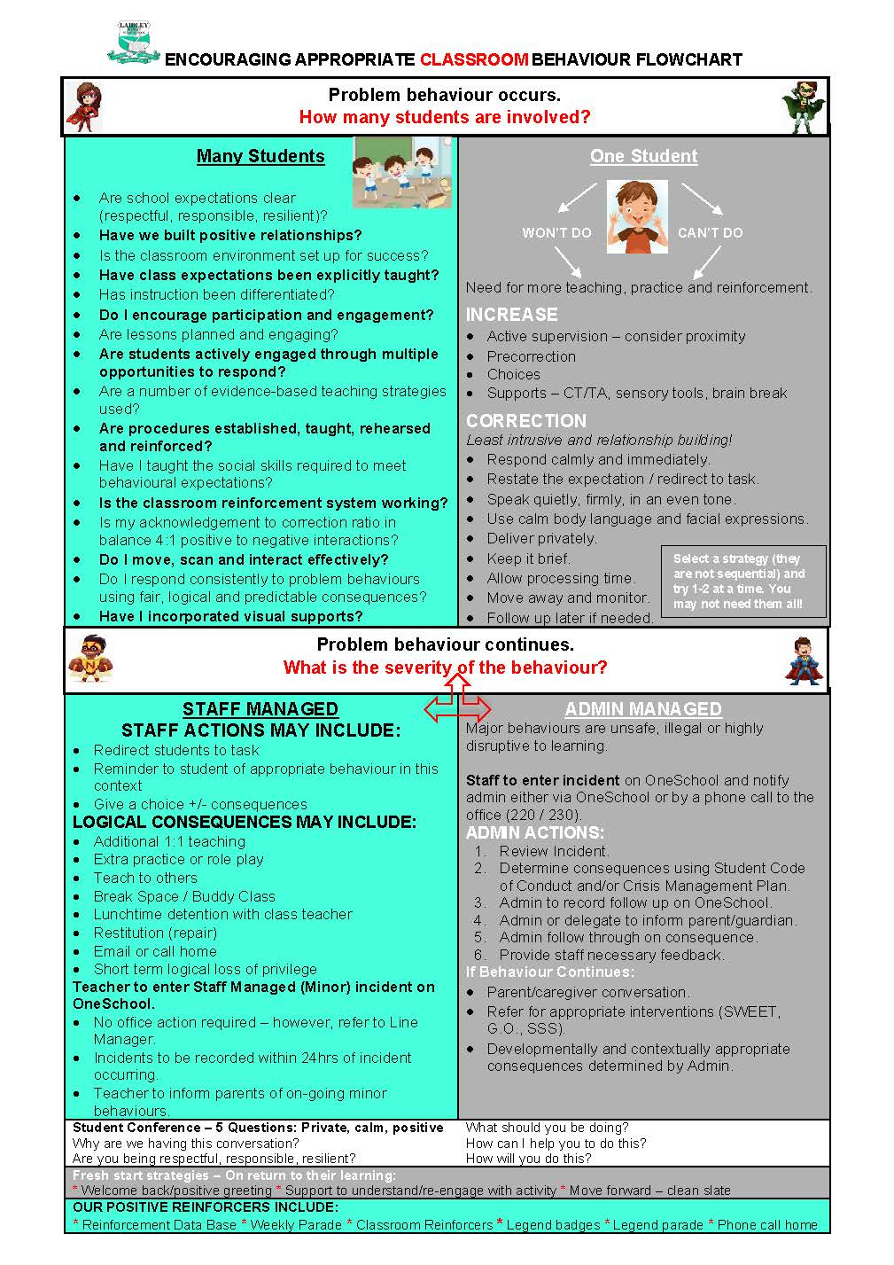

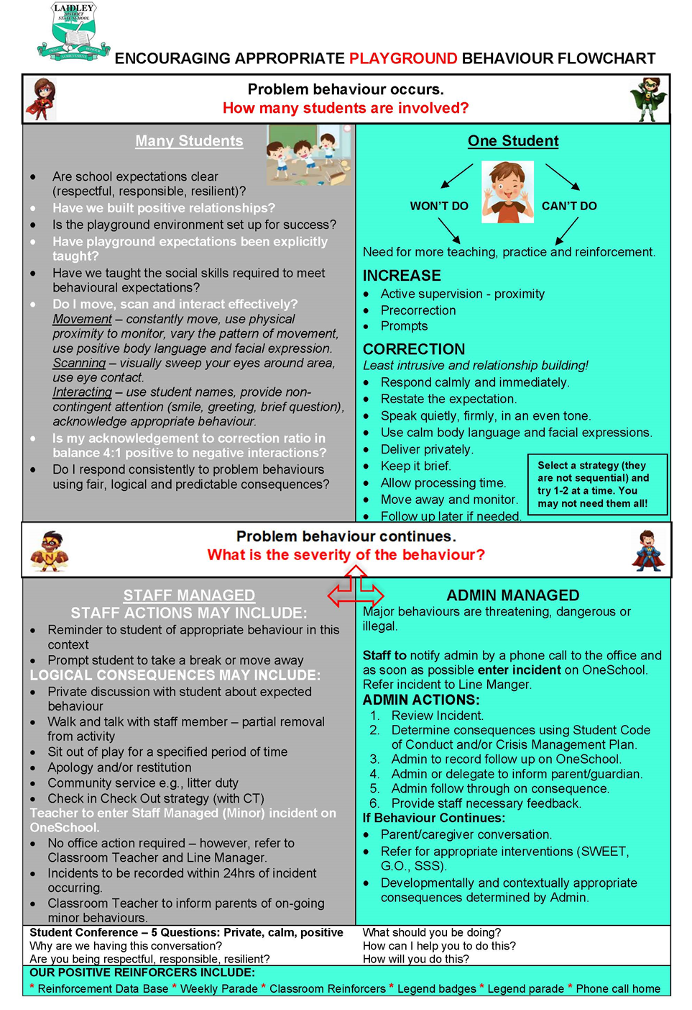

Ensuring consistent responses to problem behaviour
At Laidley District State School staff members are provided with appropriate professional development and/or training to issue consequences for problem behaviour. Through Behaviour and Well-Being training activities, we work to ensure consistent responses to problem behaviour across the school.

Students also receive Behaviour and Well-Being lessons from UR Strong Friendology 101 about how to respond when other students display problem behaviour and an explicit focus wholeschool behaviour lesson each fortnight. Students are taught strategies to deal with Mean-on-Purpose behaviours and Friendship Fires. Students are taught appropriate ways to respond when a staff member re-directs their behaviour or consequences are applied.

Bus Behaviour- All Laidley District buses run under the Code of Conduct for School Students Travelling on Buses policy in conjunction with Queensland Transport. All Bus behaviour must be reported to the bus companies so that it can be dealt with under their Code of Conduct. The school does liaise with these companies and will support consequences in line with the bus company, especially if deemed moderate or severe.

School Disciplinary Absences
A School Disciplinary Absence (SDA) is an enforced period of absence from attending a Queensland state school, applied by the Principal as a consequence to address poor student behaviour. There are four types of SDA:
- Short suspension (1 to 10 school days)
- Long suspension (11 to 20 school days)
- Charge-related suspension
- Exclusion (period of not more than one year or permanently).

At Laidley District State School, the use of any SDA is considered a very serious decision. It is typically only used by the Principal when other options have been exhausted or the student’s behaviour is so dangerous that continued attendance at the school is considered a risk to the safety or wellbeing of the school community.

Parents and students may appeal a long suspension, charge-related suspension or exclusion decision. A review will be conducted by the Director-General or their delegate, and a decision made within 40 schools days to confirm, amend/vary or set aside the original SDA decision by the Principal.

The appeal process is a thorough review of all documentation associated with the SDA decision and provides an opportunity for both the school and the family to present their case in the matter. Time is afforded for collection, dissemination and response to the materials by both the school and the family. It is important that the purpose of the appeal is understood so that expectations are clear, and appropriate supports are in place to ensure students can continue to access their education while completing their SDA.

Re-entry following suspension
Students who are suspended from Laidley District State School may be invited to attend a re-entry meeting on the day of their scheduled return to school. The main purpose of this meeting is to welcome the student, with their parent/s, back to the school. It is not a time to review the student’s behaviour or the decision to suspend, the student has already received a punishment through their disciplinary absence from school. The aim of the re-entry meeting is for school staff to set the student up for future success and strengthen home-school communication.

It is not mandatory for the student or their parents to attend a re-entry meeting. It may be offered as a support for the student to assist in their successful re-engagement in school following suspension.

Arrangements
The invitation to attend the re-entry meeting will be communicated via telephone and in writing, usually via email. Re-entry meetings are short, taking less than 10 minutes, and kept small with only the Principal or their delegate attending with the student and their parent/s.

A record of the meeting is saved in OneSchool, under the Contact tab, including any notes or discussions occurring during the meeting.

Structure
The structure of the re-meeting should follow a set agenda, shared in advance with the student and their family. If additional items are raised for discussion, a separate arrangement should be made to meet with the parent/s at a later date and time. This meeting should be narrowly focussed on making the student and their family feel welcome back into the school community.

Possible agenda:
- Welcome back to school
- Check in on student wellbeing
- Discuss any recent changes to school routine or staffing
- Offer information about supports available (e.g. guidance officer)
- Set a date for follow-up
- Thank student and parent/s for attending
- Walk with student to classroom

Reasonable adjustments
In planning the re-entry meeting, school staff will consider reasonable adjustments needed to support the attendance and engagement of the student. This includes selecting an appropriate and accessible meeting space, organising translation or interpretation services or supports (e.g. AUSLAN), provision of written and/or pictorial information and other relevant accommodations. The inclusion of support staff, such as guidance officers or Head of Special Education, may also offer important advice to ensure a successful outcome to the re-entry meeting.

School Policies
Laidley District State School has tailored school discipline policies designed to ensure students, staff and visitors work cooperatively to create and maintain a supportive and safe learning environment. Please ensure that you familiarise yourself with the responsibilities for students, staff and visitors outlined in the following policies:

- Temporary removal of student property
- Use of mobile phones and other devices by students
- Appropriate use of social media
- Preventing and responding to bullying

Temporary removal of student property
The removal of any property in a student’s possession may be necessary to promote the caring, safe and supportive learning environment of the school, to maintain and foster mutual respect between all state school staff and students. The Temporary removal of student property by school staff procedure outlines the processes, conditions and responsibilities for state school principals and school staff when temporarily removing student property.

In determining what constitutes a reasonable time to retain student property, the principal or state school staff will consider:
- the condition, nature or value of the property
- the circumstances in which the property was removed
- the safety of the student from whom the property was removed, other students or staff members
- good management, administration and control of the school.

The Principal or state school staff determine when the temporarily removed student property can be returned, unless the property has been handed to the Queensland Police Service.

The following items are explicitly prohibited at Laidley District State School and will be removed if found in a student’s possession:

- illegal items or weapons (e.g. guns, knives*, throwing stars, brass knuckles, chains)
- imitation guns or weapons
- potentially dangerous items (e.g. blades, rope)
- drugs** (including tobacco)
- alcohol
- vapes and any vape apparatis
- aerosol deodorants or cans (including spray paint)
- explosives (e.g. fireworks, flares, sparklers)
- flammable solids or liquids (e.g. fire starters, mothballs, lighters)
- poisons (e.g. weed killer, insecticides)
- inappropriate or offensive material (e.g. racist literature, pornography, extremist propaganda, clothing).
* No knives of any type are allowed at school, including flick knives, ballistic knives, sheath knives, push daggers, trench knives, butterfly knives, star knives, butter knives, fruit knives or craft knives, or any item that can be used as a weapon, for example a chisel. Knives needed for school activities will be provided by the school, and the use of them will be supervised by school staff.
Responsibilities

State school staff at Laidley District State School:
- do not require the student’s consent to search school property such as lockers, desks or laptops that are supplied to the student through the school;
- may seize a student’s bag where there is suspicion that the student has a dangerous item (for example, a knife) in their school bag, prior to seeking consent to search from a parent or calling the police;
- consent from the student or parent is required to examine or otherwise deal with the temporarily removed student property. For example, staff who temporarily remove a mobile phone from a student are not authorised to unlock the phone or to read, copy or delete messages stored on the phone;
- there may, however, be emergency circumstances where it is necessary to search a student’s property without the student’s consent or the consent of the student’s parents (e.g. to access an EpiPen for an anaphylactic emergency);
- consent from the student or parent is required to search the person of a student (e.g. pockets or shoes). If consent is not provided and a search is considered necessary, the police and the student’s parents should be called to make such a determination.

Parents of students at Laidley District State School:
- ensure your children do not bring property onto schools grounds or other settings used by the school (e.g. camp, sporting venues) that:
  - is prohibited according to the Laidley District State School Student Code of Conduct
  - is illegal
  - puts the safety or wellbeing of others at risk
  - does not preserve a caring, safe, supportive or productive learning environment
  - does not maintain and foster mutual respect;
- collect temporarily removed student property as soon as possible after they have been notified by the Principal or state school staff that the property is available for collection.

Students of Laidley District State School:
- do not bring property onto school grounds or other settings used by the school (e.g. camp, sporting venues) that:
  - is prohibited according to the Laidley District State School Code of Conduct
  - is illegal
  - puts the safety or wellbeing of others at risk
  - does not preserve a caring, safe, supportive or productive learning environment
  - does not maintain and foster mutual respect;
- collect their property as soon as possible when advised by the Principal or state school staff it is available for collection.

Use of mobile phones and other devices by students

Digital literacy refers to the skills needed to live, learn and work in a society where communication and access to information is dominated by digital technologies like mobile phones. However, the benefits brought about through these diverse technologies can be easily overshadowed by deliberate misuse which harms others or disrupts learning.

In consultation with the broader school community, Laidley District State School has determined that explicit teaching of responsible use of electronic devices is a critical component of digital literacy. The knowledge and confidence to navigate and use these technologies safely while developing digital literacy is a responsibility shared between parents, school staff and students. Students are not explicitly instructed on how to use mobile phones at Laidley District State School.

It is also agreed that time and space should be provided at school where personal technology is not permitted. As such, at Laidley District State School, all personal devices, mobile phones, tablets, etc are to be handed into the office by students when they arrive at school. These devices are kept securely in the office by staff and ticketed for student safety of collection. Personal devices are to be collected each afternoon before departing school. When submitting devices to the office, students are to ensure the devices are switched OFF. Students found to not have handed in a device will be asked to do so immediately and could be subject to disciplinary action.

Responsibilities

At all times students, while using ICT facilities and devices supplied by the school, will be required to act in line with the requirements of the Laidley District State School Student Code of Conduct. In addition students and their parents should:
- understand the responsibility and behaviour requirements (as outlined by the school) that come with accessing the department’s ICT network facilities
- ensure they have the skills to report and discontinue access to harmful information if presented via the internet or email
- be aware that:
  - access to ICT facilities and devices provides valuable learning experiences for students and supports the school's teaching and learning programs
  - the school is not responsible for safeguarding information stored by students on departmentally-owned student computers or mobile devices
  - schools may remotely access departmentally-owned student computers or mobile devices for management purposes
  - students who use a school's ICT facilities and devices in a manner that is not appropriate may be subject to disciplinary action by the school, which could include restricting network access
  - despite internal departmental controls to manage content on the internet, illegal, dangerous or offensive information may be accessed or accidentally displayed
  - teachers will always exercise their duty of care, but avoiding or reducing access to harmful information also requires responsible use by the student.

Preventing and responding to Mean On Purpose Behaviours

Laidley District State School acknowledges the Australian Student Wellbeing Framework to promote positive relationships and the wellbeing of all students, staff and visitors at the school.

Laidley District State School actively engages in the UR Strong Friendology 101 Program which explicitly targets behaviours previously known as ‘Bullying’, which are referred to within our school as ‘Mean on purpose’ behaviours.

Our staff know student learning is optimised when they feel connected to others and experience safe and trusting relationships. Students who feel secure are more likely to be active participants in their learning and to achieve better physical, emotional, social and educational outcomes. Teachers who feel valued and supported are more likely to engage positively with students and build stronger connections within the school community. Parents who are positively engaged with their child’s education leads to improved student self-esteem, attendance and behaviour at school. Enhancing the wellbeing of students and their educators delivers overall long-term social, health and economic benefits to the Australian community.

‘Bullying’ (Mean on purpose behaviours)

The agreed national definition for Australian schools describes ‘bullying’ as
- ongoing and deliberate misuse of power in relationships through repeated verbal, physical and/or social behaviour that intends to cause physical, social and/or psychological harm;
- involving an individual or a group misusing their power, or perceived power, over one or more persons who feel unable to stop it from happening;
- happening in person or online, via various digital platforms and devices and it can be obvious (overt) or hidden (covert). ‘Bullying’ behaviour is repeated, or has the potential to be repeated, over time (for example, through sharing of digital records);
- having immediate, medium and long-term effects on those involved, including bystanders. Single incidents and conflict or fights between equals, whether in person or online, are not defined as bullying.

Behaviours that do not constitute ‘bullying’ include:
- mutual arguments and disagreements (where there is no power imbalance)
- not liking someone or a single act of social rejection
- one-off acts of meanness or spite
- isolated incidents of aggression, intimidation or violence.

These behaviours are referred to (from the UR Strong program) as ‘Friendship Fires’. These conflicts are still considered serious and need to be addressed and resolved. At Laidley District State School our staff will work to quickly respond to any matters raised of this nature in collaboration with students and parents. Each incident reported to staff at Laidley District State School is addressed and investigated. Students are supported through the UR Strong processes to respond to negative situations and friendship issues. Student behaviours are tracked through OneSchool and UR Strong ‘trackers’ by individual classroom teachers. Students identified as requiring assistance as a perpetrator of ‘Mean on purpose’ behaviour or as a victim of such behaviour, are supported through steps on how to address their behaviour or reactions. Students are explicitly instructed through class lessons on how to resolve friendship issues. The program directly teaches the value of self, good friendships, how to maintain healthy relationships and how to identify unhealthy relationships.

Cyberbullying
Cyberbullying is treated at Laidley District State School with the same level of seriousness as in-person bullying. The major difference with cyberbullying however, is that unlike in-person bulling, cyberbullying follows students into their community, their homes and their bedrooms, giving them no opportunity to escape the harassment or abuse during the evening, weekends or holidays.

In the first instance, students or parents who wish to make a report about cyberbullying should approach the regular class teacher. Alternatively, the Deputy Principal can be approached directly by students, parents or staff for assistance in preventing and responding to cyberbullying.

It is important for students, parents and staff to know that state school principals have the authority to take disciplinary action to address student behaviours that occur outside of school hours or school grounds. This includes cyberbullying. Parents and students who have concerns about cyberbullying incidents occurring during school holidays should immediately seek assistance through the Office of the e-Safety Commissioner or the Queensland Police Service.

Students enrolled at Laidley District State School may face in-school disciplinary action, such as detention or removing of privileges, or more serious consequences such as suspension or exclusion from school for engaging in behaviour that adversely affects, or is likely to adversely affect, other students or the good order and management of the school. This includes behaviour such as cyberbullying which occurs outside of school hours or settings, for example on the weekend or during school holidays. It also applies to inappropriate online behaviour of enrolled students that is directed towards other community members or students from other school sites.

Parents or other stakeholders who engage in inappropriate online behaviour towards students, staff or other parents may be referred to the Office of the e-Safety Commissioner and/or the Queensland Police Service. State school staff will be referred for investigation to the Integrity and Employee Relations team in the Department of Education. Any questions or concerns about the school process for managing or responding to cyberbullying should be directed to the principal.

Laidley District State School - Continued ‘Mean On Purpose’ © (Bullying) response flowchart for teachers
Please note these timelines may be adjusted depending on the unique circumstances and risk associated with each situation. This is at the professional judgment of the staff involved.
Key contacts for students and parents to report bullying:
Prep to Year 6 – Class teacher
Deputy Principal / Principal – 07 5466 8222

- Meet with the student to review situation
- Discuss what has changed, improved or worsened
- Explore other options for strengthening student wellbeing or safety
- Report back to parent
- Record outcomes in OneSchool (behaviour incident if applicable and records of contact)
Review
- Document the plan of action in OneSchool (Admin follow up/Record of Contact)
- Complete ‘Mean on purpose’ behaviour action plan, where appropriate
- Monitor the student and check in regularly on their wellbeing
- Seek assistance from student support network if needed
Implement
Listen
- Provide a safe, quiet space to talk
- Reassure the student that you will listen to them
- Let them share their experience and feelings without interruption
- If you hold immediate concerns for the student's safety, let the student know how you will address these. Immediate in this circumstance is where the staff member believes the student is likely to experience harm (from others or self) within the next 24 hours
- Continue to check in with student on regular basis until concerns have been mitigated
- Refer to member of Admin, if concerns still persist
- Record notes of follow-up meetings in OneSchool
- Look for opportunities to improve school wellbeing for all students
Follow up
- Evaluate the information to determine if bullying has occurred or if another disciplinary matter is at issue
- Make a time to meet with the student to discuss next steps
- Ask the student what they believe will help address the situation
- Provide the student and parent with information about student support network

Discuss
- Ask the student for examples they have of the alleged continued ‘Mean on purpose’ behaviour (bullying) e.g. hand written notes or screenshots
- Write a record of your communication with the student
- Check back with the student to ensure you have the facts correct
- Enter the record in OneSchool – record of contact
- Notify parent/s that the issue of concern is being investigated
Document
- Gather additional information from other students, staff or family
- Review any previous reports or records for students involved
- Make sure you can answer who, what, where, when and how
- Clarify information with student and check on their wellbeing
Collect
Appropriate use of social media

The internet, mobile phones and social media provide wonderful opportunities for students to network and socialise online. While these technologies provide positive platforms for sharing ideas, they also have the potential to cause pain and suffering to individuals, groups or even whole communities.

It’s important to remember that sometimes negative comments posted about the school community have a greater impact than expected. This guide offers some information about how to use social media in relation to comments or posts about the school community. Reputations of students, teachers, schools, principals and even parents can be permanently damaged — and in some cases, serious instances of inappropriate online behaviour are dealt with by police and the court system.

Being aware of a few simple strategies can help keep the use of social media positive and constructive:
- Before you post something online, ask yourself if the community or individual really need to know. Is it relevant, positive and helpful?
- Remember that what you post online is a direct reflection of who you are. People will potentially form lasting opinions of you based on what you post online.
- Be a good role model. If things get heated online consider logging out and taking a few moments to relax and think. Hasty, emotive responses could inflame situations unnecessarily.
- Be mindful when commenting, try to keep general and avoid posting anything that could identify individuals.
- A few years ago parents may have discussed concerns or issues with their friends at the school gate. Today with the use of social media, online discussions between you and your close friends can very quickly be shared with a much wider audience, potentially far larger than intended.
- Taking a few moments to think about the content you are about to post could save upset, embarrassment, and possible legal action.
- As a parent you have a role in understanding legislation around social media guidelines, supervising and regulating your child’s online activities at home and its impact on the reputation and privacy of others. Parents are their child’s first teachers — so they will learn online behaviours from you.

Is it appropriate to comment or post about schools, staff or students?

Parental and community feedback is important for schools and the department. If you have a compliment, complaint or enquiry about an issue at school, the best approach is to speak directly to the school about the matter, rather than discussing it in a public forum.

While many schools use social media to update parents of school notices, the department prefers that parents contact schools directly with a compliment, complaint or enquiry due to privacy considerations. Imagine if your doctor, accountant or banking institution tried to contact you to discuss important matters via Facebook.

If you have raised an issue with a school or know that another person has, consider refraining from discussing those details on social media, particularly the names of anyone involved.

Keep comments calm and polite, just as you would over the telephone or by email. If you encounter negative or derogatory content online which involves the school, hinders a child’s learning and/or affects the school community at large, contact the school principal.

Possible civil or criminal ramifications of online commentary

A serious instance of inappropriate online behaviour may constitute a criminal offence and become a police matter. For example, online content may substantiate the offence of ‘using a carriage service to menace, harass or cause offence’ (Criminal Code Act 1995 (Cth) s. 474.17). School staff may contact their union or obtain personal legal advice if they feel that online content seriously impacts their reputation. Defamatory online content may give rise to litigation under the Defamation Act 2005 (Qld).

What about other people’s privacy?

If you upload photos of your children, be mindful of who might be in the background. You might be happy to share your child’s successes with your friends and family via social media, but some parents are not. If you are tagging or naming students, consider that other parents may not want their child’s name attached to images online.

What if I encounter problem content?

Taking the following steps may help resolve the issue in a constructive way:
- refrain from responding
- take a screen capture or print a copy of the concerning online content
- if you consider problem content to be explicit, pornographic or exploitative of minors, you should keep a record of the URL of the page containing that content but NOT print or share it. The URL can be provided to the school principal, or police, as needed for escalation of serious concerns
- block the offending user
- report the content to the social media provider.

Cyberbullying response flowchart for school staff

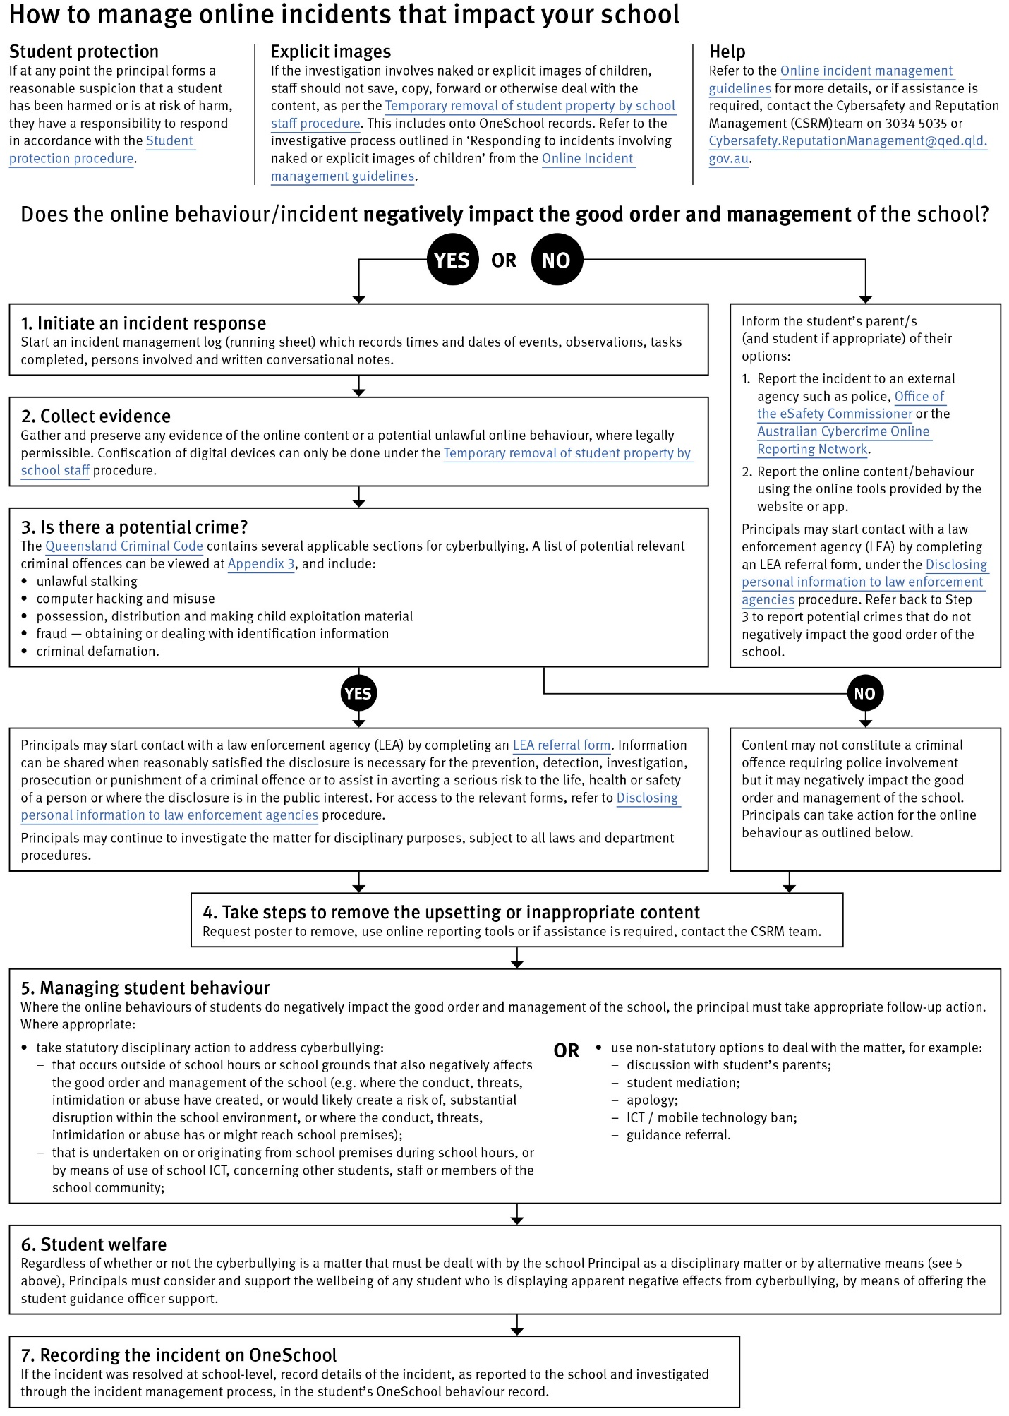

Restrictive Practices

School staff at Laidley District State School need to respond to student behaviour that presents a risk of physical harm to the student themselves or others. It is anticipated that most instances of risky behaviour can be de-escalated and resolved quickly. On some rarer occasions, a student’s behaviour may continue to escalate and staff need to engage immediately with positive and proactive strategies aimed at supporting the student to manage their emotional arousal and behaviour.

In some very rare situations, where there is immediate risk of physical harm to the student or other people, and when all other alternative strategies have failed to reduce the risk, it may be necessary for staff to use restrictive practices. Examples of these instances include, but are not limited to;
- using manual guidance to prevent a student running onto a busy road
- holding a student or using seclusion to prevent them physically attacking another student or staff member
- holding a students hand to prevent repetitive, serious, self-injuries behaviour

The use of restrictive practices will always be as a last resort, when there is no other available option for reducing immediate risk to the student, staff or other people. Restrictive practices are not used for punishment or as a disciplinary measure.

The department’s Restrictive practices procedure is written with consideration for the protection of everyone’s human rights, health, safety and welfare. There are six fundamental principles:

- Regard to the human rights of those students
- Safeguards students, staff and others from harm
- Ensures transparency and accountability
- Places importance on communication and consultation with parents and carers
- Maximises the opportunity for positive outcomes, and
- Aims to reduce or eliminate the use of restrictive practices.

Very rarely restrictive practices will be planned and staff will employ, when necessary, pre-arranged strategies and methods (of physical restraint/ mechanical restraint/ clinical holding) which are based upon behaviour risk assessment or clinical health need and are recorded in advance. The use of planned strategies will only be where there is foreseeable immediate risk consistent with the Restrictive practices procedure.

Seclusion will not be used as a planned response and will only be used in serious circumstances for managing an unforeseeable situation in an emergency. It will be used for the shortest time possible and in a safe area that presents no additional foreseeable risk to the student. In such emergencies, a staff member will observe the student at all times and seclusion will cease as soon as possible.

Following the use of any restrictive practice, a focused review will help staff to understand how they responded to the risk in any incident that involved the use of a restrictive practice. Staff will consider whether there are other options for managing a similar situation in the future. This strategy works well for reducing the use of restrictive practices.

All incidents of restrictive practices will be recorded and reported in line with departmental procedures.

Critical Incidents

It is important that all school staff have a consistent understanding of how to respond in emergencies involving student behaviour that seriously endangers the student or others. This consistency ensures that appropriate actions are taken to ensure that both students and staff are kept safe.

A critical incident is defined as an occurrence that is sudden, urgent, and usually unexpected, or an occasion requiring immediate action (e.g. in the community, on the road). The aim in these situations is to bring the behaviour of the student under rapid and safe control. It is not a time to try and to punish or discipline the student; it is a crisis management period only.

Staff should follow the documented plan for any student involved in regular critical incidents, which should be saved and available for staff to review in OneSchool.

For unexpected critical incidents, staff should use basic defusing techniques:

- Avoid escalating the problem behaviour: Avoid shouting, cornering the student, moving into the student’s space, touching or grabbing the student, sudden responses, sarcasm, becoming defensive, communicating anger and frustration through body language.

- Maintain calmness, respect and detachment: Model the behaviour you want students to adopt, stay calm and controlled, use a serious measured tone, choose your language carefully, avoid humiliating the student, be matter of fact and avoid responding emotionally.

- Approach the student in a non-threatening manner: Move slowly and deliberately toward the problem situation, speak privately to the student/s where possible, speak calmly and respectfully, minimise body language, keep a reasonable distance, establish eye level position, be brief, stay with the agenda, acknowledge cooperation, withdraw if the situation escalates.

- Follow through: If the student starts displaying the appropriate behaviour briefly acknowledge their choice and re-direct other students’ attention towards their usual work/activity. If the student continues with the problem behaviour, then remind them of the expected school behaviour and identify consequences of continued unacceptable behaviour.

Debrief: At an appropriate time when there is low risk of re-escalation, help the student to identify the sequence of events that led to the unacceptable behaviour, pinpoint decision moments during the sequence of events, evaluate decisions made, and identify acceptable decision options for future situations.

Related Procedures and Guidelines

These are related procedures or guidelines which school staff use to inform decisions and actions around matters associated with students wellbeing, behaviour and learning. This may include reference to

- Complex case management
- Customer complaints management policy and procedure
- Disclosing personal information to law enforcement agencies
- Enrolment in state primary, secondary and special schools
- Hostile people on school premises, wilful disturbance and trespass
- Inclusive education
- Police and Child Safety Officer interviews and searches with students
- Restrictive practices
- Refusal to enrol – Risk to safety or wellbeing
- Student discipline
- Student dress code
- Student protection
- Supporting students’ mental health and wellbeing
- Temporary removal of student property by school staff
- Use of ICT systems
- Using mobile devices

Resources

- Australian Professional Standards for Teachers

- Behaviour Foundations professional development package (school employees only)

- UR Strong

- eheadspace

- Kids Helpline

- Office of the eSafety Commissioner

- Parent and community engagement framework

- Parentline

- Queensland Department of Education School Discipline

- Raising Children Network

- Student Wellbeing Hub

Conclusion

Laidley District State School staff are committed to ensuring every student is supported to feel safe, welcome and valued in our school. There may, however, be occasions where parents need to raise a concern or make a complaint about an issue you feel is adversely affecting your child's education.

All Queensland state schools are committed to ensuring that all complaints - whether they relate to a school staff member or a school's operations - are dealt with in a fair and equitable manner. As a parent or carer, you can express dissatisfaction with the service or action of the Department of Education or its staff, including decisions made or actions taken in a school and/or by the local regional office.

As a complainant, it is your responsibility to:
- give us a clear idea of the issue or concern and your desired solution
- provide all the relevant information when making the complaint
- understand that addressing a complaint can take time
- cooperate respectfully and understand that unreasonable, abusive, or disrespectful conduct will not be tolerated
- let us know if something changes, including if help is no longer needed.

The Department of Education may not proceed with your complaint if your conduct is unreasonable.

In most instances, staff members are told of complaints made about them and offered the right of reply. A complainant also has the right to have a support person throughout the process.

The following three-step approach assists parents and school staff in reaching an outcome that is in the best interests of the student:

- Early resolution: discuss your complaint with the school
The best place to raise any concerns is at the point where the problem or issue arose. You can make an appointment at the school to discuss your complaint with your child’s teacher or the principal. You are also welcome to lodge your complaint in writing or over the phone. You can also make a complaint through QGov.

Complaints may be lodged by telephone, writing or in electronic format. Email addresses can be accessed through the schools directory.

- Internal review: contact the local Regional Office
If, after taking the early resolution step, you are dissatisfied with the outcome of your complaint or how the complaint was handled, you can ask the local regional office to conduct a review. You need to submit a Request for internal review form within 28 days of receiving the complaint outcome.
- External review: contact a review authority
if you are dissatisfied after the internal review, you may wish to contact a review authority, such as the Queensland Ombudsman, and request an independent, external review. More information about external review options is available at www.ombudsman.qld.gov.au.

Some matters need to be handled in a different way to school matters and will be referred to other areas in the department. These include:
- issues about harm, or risk of harm, to a student attending a state school, which must be managed in accordance with the Student protection procedure.
- complaints about corrupt conduct, public interest disclosures; or certain decisions made under legislation, which will be dealt with as outlined in the Excluded complaints factsheet.

